**Task: 09**

**Serial Communication**



**Spring-22**

[**CSE-307 Micropro**](https://classroom.google.com/u/2/c/MzA5OTAwMDgwMjI2)**cessor Based System Design**

Submitted by: **Ashfaq Ahmad**

Registration No: **19PWCSE1795**

Class Section: **B**

“On my honor, as a student of the University of Engineering and Technology, I have neither given nor received unauthorized assistance on this academic work.”

Student Signature: ______________

Submitted to:

**Dr. Bilal Habib**

July 11, 2022

Department of Computer Systems Engineering

University of Engineering and Technology, Peshawar

1. Frequency of the input sine wave (**f_in**) is 50Hz.

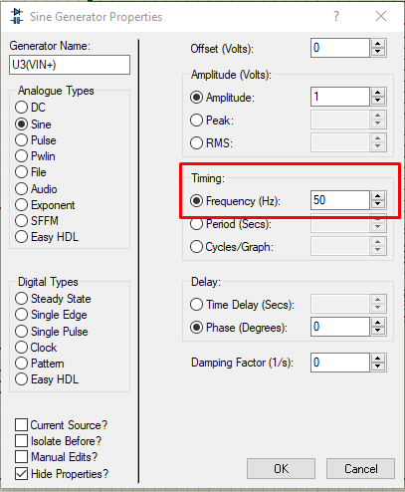

1. Sampling rate (**fs)** of ADC = 500 samples/sec.
2. Transmission rate of serial data is 9600 bps between MCU-1 and MCU-2.

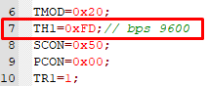

1. Oscillator frequency = 11.059MHz.

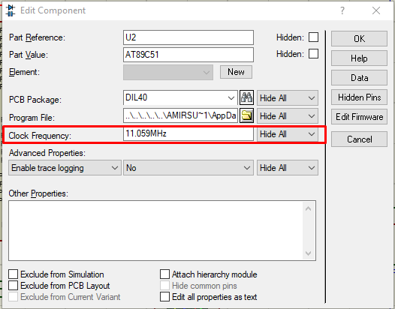

**Code:**

**uC1:**

|  |
| --- |
| #include<reg51.h>  #include<stdio.h>  #defineinput P1;  *double*DG_signal;  // ADC pins  sbit Read = P3 ^3;  // rd pin will use for reading  sbit Write = P3 ^4; // wr pin will use for writing  sbit INTR = P3 ^2;  // intr is used for interrupt  *void* Analogue_to_digital()  {      Read =1;  // high to low to read from adc      Write =0; // low to high to write on adc      // delay(1);      Write =1;      while (INTR ==1)          ; // low active interrupt      Read =0;  }  *void*main(*void*) //microcontroller configuration  {      TMOD =0x20; // Auto Reload Mode of Timer1      TH1 =0xFD;      SCON =0x50; //SM1=1 REN=1;      PCON =0x00; //bit rate not double      TR1 =1; // Set TImer1      while (1)      {          Analogue_to_digital();          SBUF =input; // register for serial communication          while (TI ==0)              ; /// when the transmission done the T1==0          TI =0;      }  } |

**uC2:**

|  |
| --- |
| #include<reg51.h>  #include<stdio.h>  *unsignedint* y;  *void*main(*void*)  {      TMOD =0x20;      TH1 =0xFD; // bps 9600      SCON =0x50;      PCON =0x00;      TR1 =1;      while (1)      {          while (RI ==0)              ; // Stays here until the Data is received          RI =0;          P1 = SBUF; // Throws the output data to P1      }  } |

**Schematic:**

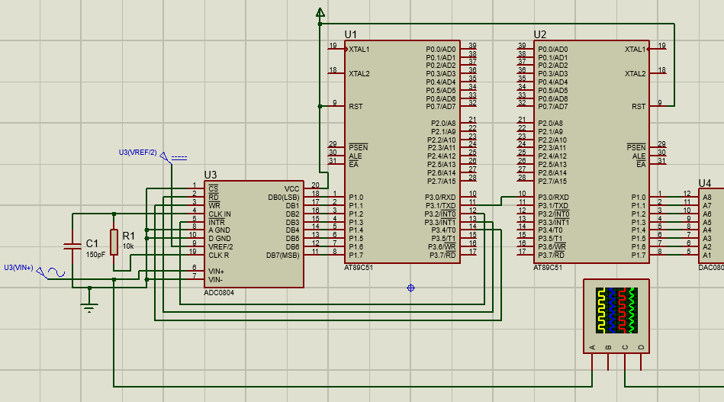

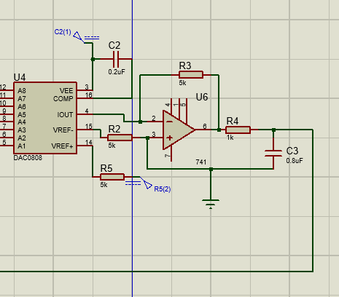

**Output:**

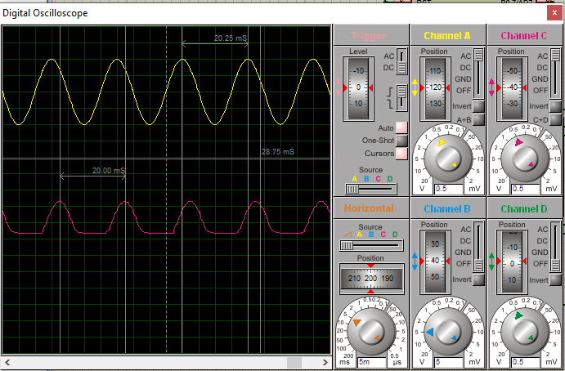

1. If oscillator frequency is fixed at 22.118MHz for both microcontrollers. Keeping in view the *fastest possible transmission* rate of serial communication and *ADC conversion rate*. How much the frequency of the input signal can be increased? Run the system at that frequency in Proteus.



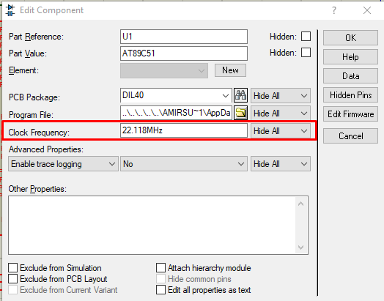

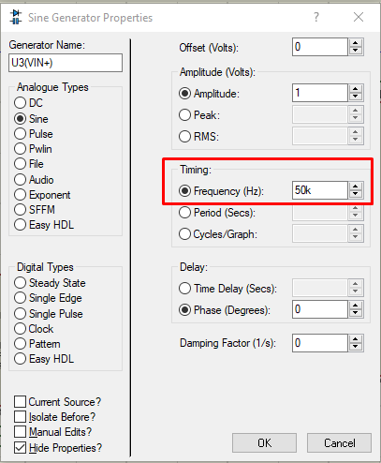

We can increase the frequency up to 50kHz for such a configuration but the sine waveform gets destroyed with time.

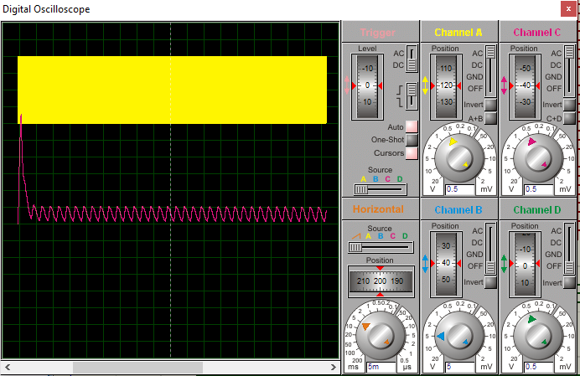

1. **Discuss,**

* **Input signal to ADC has a frequency (f_in) of 50Hz. How you supplied it**.

**Answer;**

I applied this frequency by editing the properties of the sine wave generator as shown in screenshot1 of this document.

* **What happens if you decrease the sampling rate (fs) from 500Hz, 400Hz to 100Hz samples per second for ADC?**

**Answer;**

If I decrease the sampling rate from 500Hz down to 100Hz samples per second, then the waveform will get destroyed because we do not keep adequate samples to reform the original signal.

* **What reference voltage (V_ref) has been used for ADC?**

**Answer;**

I used V_ref/2 as 2.5V which will make V_ref as 5V.

* **What is the relationship of V_ref to the amplitude of the input signal?**

**Answer;**

There is a direct relation of V_ref to the amplitude of the input signal.

* **What will be the step size?**

**Answer;**

Step size is given by Vin/2n so in my case, the step size will become 5/28 = 5/256 = 19.5mV.

* **What is the input voltage range of ADC?**

**Answer;**

As my reference voltage is 5V so, the input voltage range of my ADC is 0V -5V.

* **Can we increase the frequency of input signal (f_in) to 10KHz, if not then why?**

**Answer;**

we cannot increase the frequency of the input signal to 10KHz because we will need a sampling frequency of 1MHz for that, which is practically not possible to achieve.

* **If the transmission rate is increased to 19,200 bps. Is your design able to handle input frequency (f_in) equal to 10KHz, without any loss of information? Assuming fs = = 10 x f_in.**

**Answer;**

No, our design can not handle such a frequency if the transmission rate is increased to 19200bps because the transmission will take place so fast that the design will lose the information.

* **What is the limit of DAC, and how fast it can work?**

**Answer;**

The limit of the DAC is the number of DAC outputs = 2n = 28= 256.

The transmission time of DAC is 150 ns which is very fast

**Bonus** Part: Clean out the output of DAC using some low-pass RC filter. Like the one shown below, start from using small values of Capacitor like 10nF and go on increasing it.

**Answer;**

For smooth output, I used the following circuit at the end of the schematic.

